|  |
| --- |
| **JDN Standards – C-MOR** |

Introduction 1

Prerequisite 1

Installation CMOR 1

Foscam FI9901EP 5

Dahua DH-IPC-HDW2431RP-ZS 6

# Introduction

This document provides guidelines for deployment of the C-MOR Surveillance software on board of our JDN Vessels. We install the software as an appliance on the VMware environment.

# Prerequisite

* Upload the ISO to the ISO-folder on VirtualDisk1R6
* The software can register the license on outgoing https connection: TCP port 443
* Machine Network:
  + XX-CMOR01: 10.X.X.172
  + XX-CAM01: 10.X.X.173
  + XX-CAM02: 10.X.X.174

# Installation CMOR

1. Create a new virtual Machine in vCenter
2. Name: **XX-CMOR01**Location: **Linux Servers**

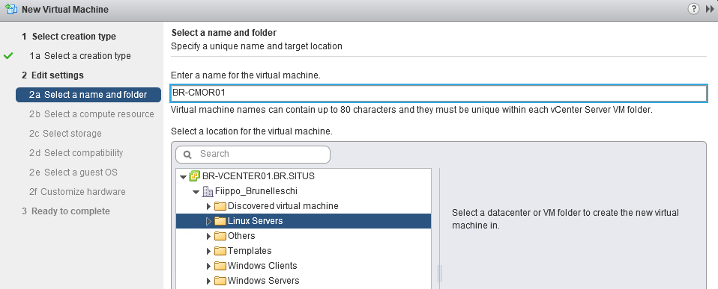

1. Select a compute resource
2. Select Storage
3. Select compatibility: **ESXi 6.5**
4. Select guest OS: **Other 2.6x Linux (64-bit)**
5. Customize hardware
   1. CPU: 2
   2. Memory: 1GB
   3. Hard Disk: 500 GB
   4. Network: Machine
   5. CD: mount the iso

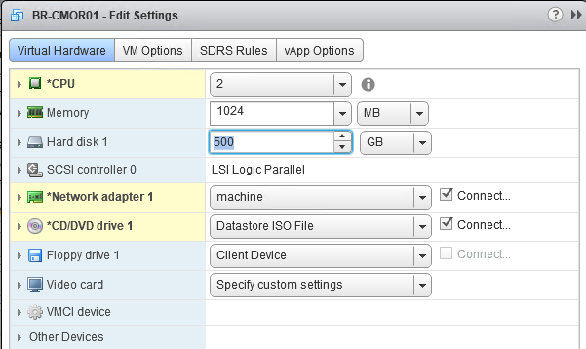

1. Boot the VM and open console
2. Select “Automatically” installation
3. Change the IP Settings  
   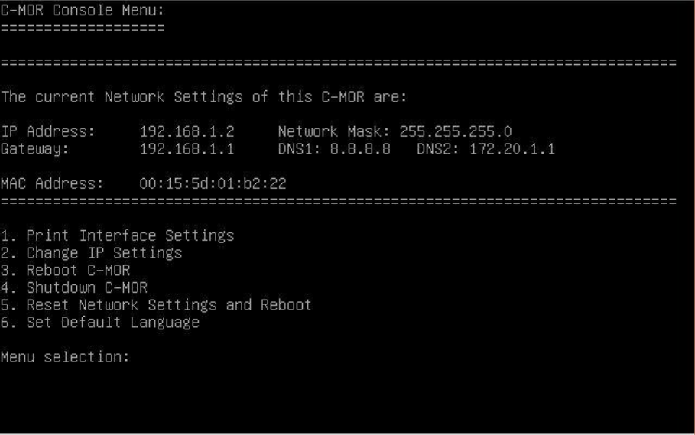
   1. IP Address: 10.X.X.172 (Machine range)
   2. Network Mask: 255.255.255.0
   3. Gateway: 10.X.X.1 (Machine range)
   4. DNS: 10.X.X.11 (admin-trust)
4. Open the web-browser and open **http://10.x.x.172** Default username and password is **admin**
5. Accept the Disclaimer
6. After accepting the disclaimer you are on the start page of C-MOR:  
   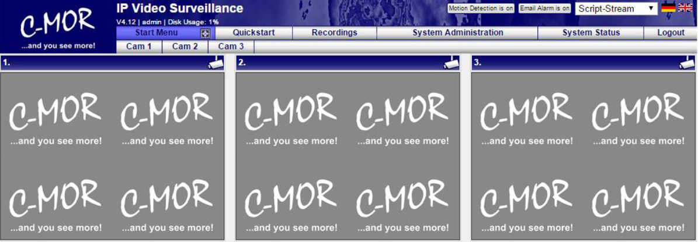
7. Register the License
   1. Got to **System Administration > License Installation**
   2. Enter the username & password
8. Set system name
   1. Go to **System Administration > System Name**
   2. Name: XX-CMOR01
9. Set Time
   1. Enter the XX-DC01 ip
10. Storage Time Of Recordings
    1. Delete Recordings after 30 days for all camera’s
11. User Administration
    1. Reset the Administrator password
    2. Add ADL_TSE user
12. Add Camera
    1. Enter the camera IP address
    2. Enter the TCP-IP-PORT
    3. Enter the camera username and password
    4. Select Cam Type
       1. Protocol: **rtsp://**
       2. Manual Path: **/live**
          1. Foscam manual path: **/videoMain**
    5. Camera Settings
       1. Image Size: **1280 x 720**
       2. Recording length of time-lapse recordings: **Hourly**
       3. Enable JPEG images in motion detection mode: **Off**
       4. Recording mode: **Motion detection**
       5. Superimpose text in the video image: **XX-CAM01, XX-CAM02**
       6. Use TCP when selected RTSP connection: **ON**
13. Save Configuration
14. Disable motion detection

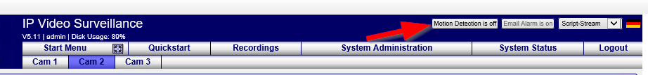

# Foscam FI9901EP

1. Login with: admin / admin
2. Basic Settings
   1. Camera name: **XX-CAM01, XX-CAM02**
   2. Camera time: Set the **time zone** & **Device time** to **UTC**
   3. User Accounts:
      1. set the **Administrator** password
      2. Add **ADL_TSE**
3. Network
   1. IP Configuration
      1. Uncheck DHCP
      2. Set fixed IP address. Machine range.214, .215, .216
   2. Mail settings
      1. Uncheck enable
4. Video
   1. Video Settings
      1. Stream type: **user-defined**
      2. Resolution: **1080p**
      3. Bit rate: **4M**
      4. Frame rate: **25**
      5. Key frame interval: **30**
      6. Rate Control Mode: **VBR**
5. Detector
   1. Motion detection
      1. Uncheck enable

# Dahua DH-IPC-HDW2431RP-ZS

1. Login with admin / admin
2. Settings
   1. Camera
      1. Video
         1. Resolution: **1920*1080 (1080p)**
         2. Frame rate: **25**
         3. Bit rate type: **VBR**
         4. Quality: **4**
   2. Network
      1. TCP/IP
         1. Uncheck DHCP
         2. Set fixed IP address. Machine range.214, .215, .216
   3. Event
      1. Video Detection
         1. Uncheck enable
   4. System
      1. General
         1. Set time zone to **UTC**
         2. Set time to **UTC time**
      2. Account
         1. Change Administrator password
         2. Add **ADL_TSE** user